Subject: Programming with Java
ASSIGNMENT No : 1
TITLE :Develop an application based on Java environment setup, JDK/JRE/JVM, variables, methods and constructors. and demonstrate the implementation of the concepts through suitable examples.

Problem Statement
Develop an application based on Java environment setup, JDK/JRE/JVM, variables, methods and constructors. and demonstrate the implementation of the concepts through suitable examples.

Learning Objectives
Understand the theoretical concepts, implement them in Java programs, analyze outputs, and apply the concepts to solve practical programming problems.

Theory
Java environment setup, JDK/JRE/JVM, variables, methods and constructors. forms an important component of Java programming. Students should understand the underlying concepts, architecture, advantages, use cases, and implementation methodology. The exercise should focus on understanding the design principles, coding practices, execution flow, and practical applications of these concepts in software development. Detailed study should include syntax, APIs, execution process, and real-world applications.

The core components of Java and their relationship(diagrams):

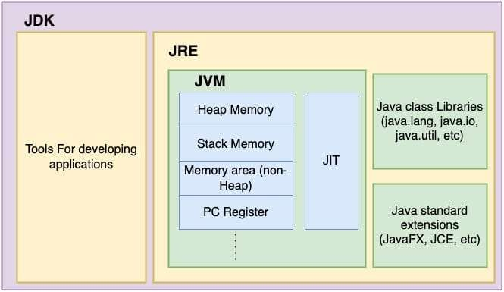

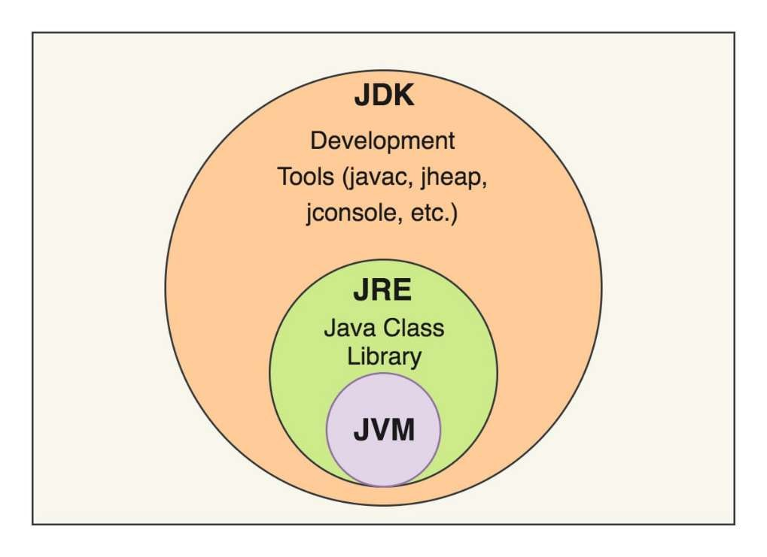

This is the JVM (Java Virtual Machine) Architecture:
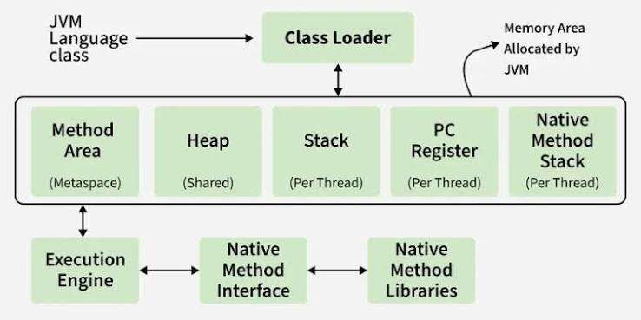

Code:

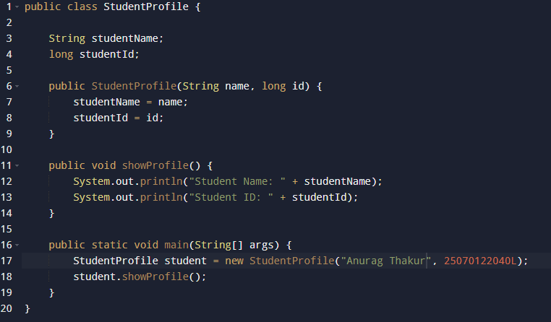

Output Screenshot

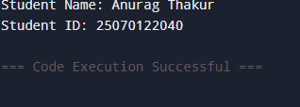

Conclusion
Hence, the Java development environment was successfully configured after updating the VS Code settings.json path to reference a modern JDK 17+ installation, which resolved a background language server crash. A complete application was designed and successfully executed, proving the integration of object-oriented structures such as classes, constructors, methods, and variables. During implementation, a numerical overflow syntax issue was resolved by refactoring the PRN identifier datatype from a 32-bit int to a 64-bit long to safely accommodate the large 11-digit value. Furthermore, debugging and deployment roadblocks were cleared by manually terminating a deadlocked background runtime process and resolving terminal syntax flag typos during version control initialization, resulting in a clean, working source tree successfully pushed to GitHub.

Questions
1. Explain the main concept used in Java environment setup, variables and methods.
Ans.
- Environment Setup: Java applications require the JDK (Java Development Kit) to compile human-readable source code into bytecode. The JRE (Java Runtime Environment) bundles the core class libraries and the JVM (Java Virtual Machine) to run that bytecode, rendering the software platformindependent.
- Variables: They function as named allocation blocks in system memory that hold specific data types (such as String or long), effectively maintaining the real-time state of an object.
- Methods: They are structured blocks of code designed to perform specific operations or logical computations, defining the behaviors of a class and keeping code modular

2. What are the real-world applications?
Ans.
- Enterprise Web Applications: Java is widely used for building secure, scalable, and large-scale backend systems for banking, e-commerce, and reservation platforms (e.g., handling user profiles and data processing).
- Android App Development: Native Android mobile applications rely heavily on Java’s class-based structure, utilizing constructors for object initialization and methods for UI interactions.
- Big Data & Cloud Systems: Major distributed data processing frameworks, such as Apache Hadoop and Apache Spark, use Java for heavy calculation pipelines and high-throughput server architecture.

